KENDRIYA VIDYALAYA CRPF PALLIPURAM
HOLIDAY HOMEWORK- SUMMER BREAK
2021-22
CLASS – VII MATHEMATICS

I. MCQ WORKSHEET -INTEGERS
Read the questions and select the correct answer from the following:
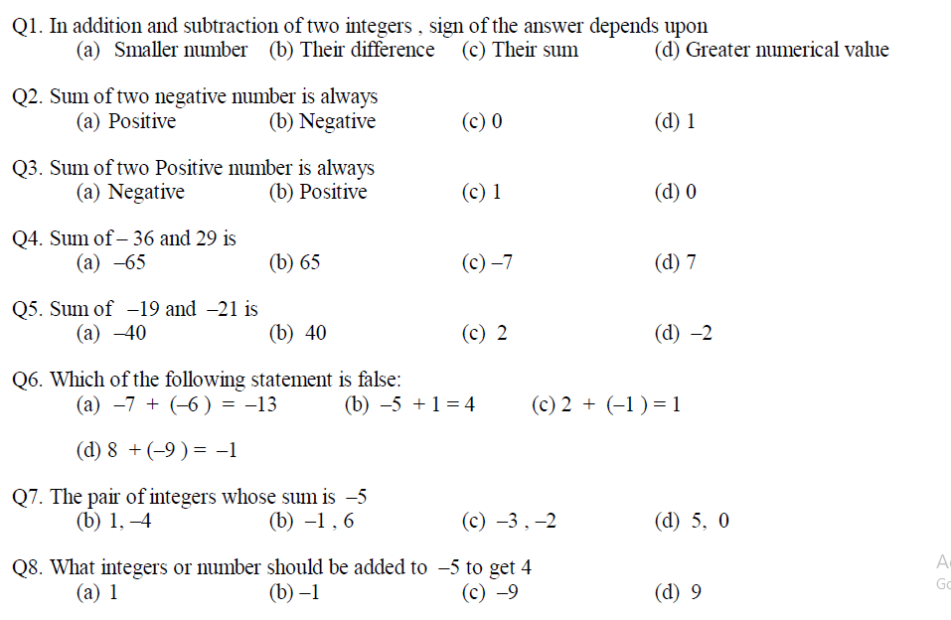

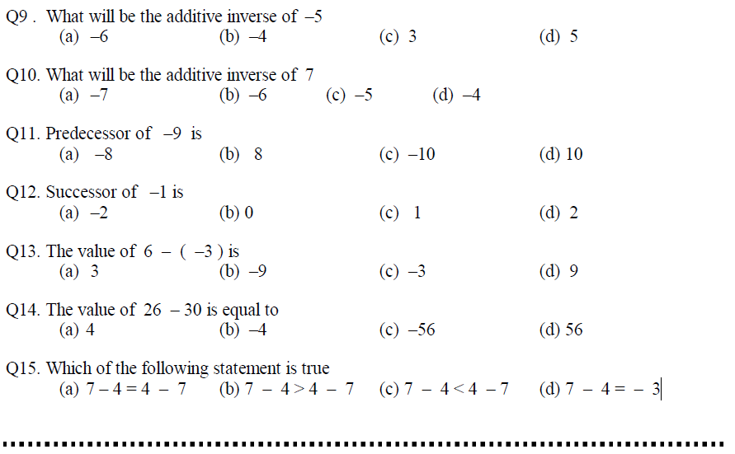
II Answer the following questions:

